## Adding New Visio Templates and Shapes (QRC)

## Introduction

This QRC provides the steps to add the Office of Modern Architecture (OMA) supported Visio Templates and Shapes for creation of architecture models.

**NOTE:** These instructions can be used to download any of the available stencil packs shown in step 3 of "**Instructions to add new Visio Shapes**".

## Instructions to add new Visio Shapes

1. Click below **link** to open EMAF templates SharePoint folder

[EMAF Templates Folders](https://ishareteam2.na.xom.com/sites/at/ea/Shared%20Documents/Forms/List%20View.aspx?RootFolder=%2Fsites%2Fat%2Fea%2FShared%20Documents%2FTemplates&FolderCTID=0x01200008954B16A7298740A1C9401572C6139B&View=%7B95942D89%2DD7DA%2D4E9B%2D99D2%2DE6145BA641AD%7D)

1. Click on **EMAF-templates** ZIP file to download the file

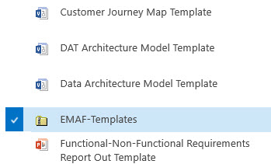

1. Once the **What do you want to do...** dialog box is displayed, click the **Save ->** **Save as** option



1. From File Explorer, navigate to your network account LocalData folder --> **C:\Users\<your-id>\LocalData\My Templates** directory and save to **My Templates**

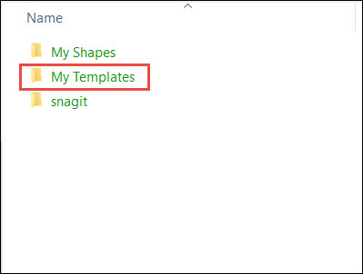

1. Right click on saved zip file and select **Extract All** option to extract the contents of zip file

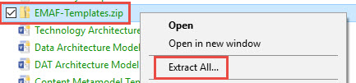

1. Once the **Destination and Extract Files** dialog box is displayed, browse to select **C:\Users\<your-id>\LocalData\My Templates** directory on your PC

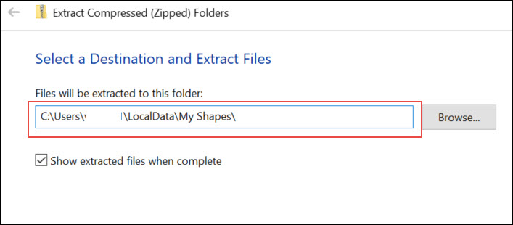

## Instructions to add new Visio Shapes

1. Click below **link** to open EMAF stencils SharePoint folder

[EMAF Stencils Folder](https://ishareteam2.na.xom.com/sites/at/ea/Shared%20Documents/Forms/List%20View.aspx?RootFolder=%2Fsites%2Fat%2Fea%2FShared%20Documents%2FStencils&FolderCTID=0x01200008954B16A7298740A1C9401572C6139B&View=%7B95942D89%2DD7DA%2D4E9B%2D99D2%2DE6145BA641AD%7D)

1. Click on **EM Architecture Framework** ZIP file to download the file

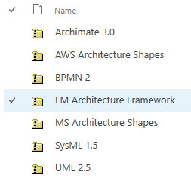

1. Once the **What do you want to do...** dialog box is displayed, click the **Save as** option



1. From File Explorer, navigate to your network account LocalData folder --> **C:\Users\<your-id>\LocalData\My Shapes** directory and save to **My Shapes**

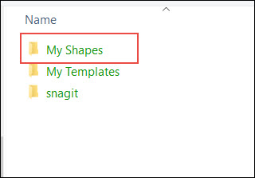

1. Right click on saved zip file and select **Extract All** option to extract the contents of zip file

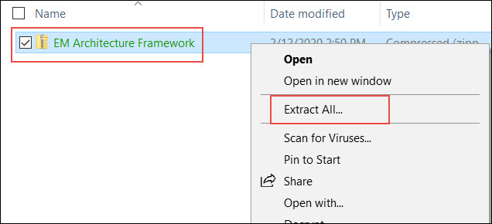

1. Once the **Destination and Extract Files** dialog box is displayed, browse to select **C:\Users\<your-id>\LocalData\My Shapes** directory on your PC



1. Repeat steps 3 – 7 for other stencil packs you may want to use

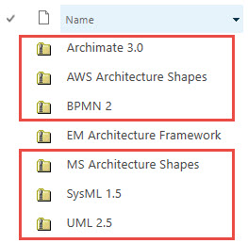

NOTE: The following stencil packs are only used for illustrations:

* Archimate 3.0
* AWS Architecture Shapes
* MS Architecture Shapes

## TIP: Pin to Quick Access

1. In File Explorer, in order to avoid navigation across multiple levels, **My Templates** and **My Access** can be added to Quick Access.
2. From File Explorer, navigate to your network account **LocalData** folder --> **C:\Users\<your-id>\LocalData\My Shapes** directory.
3. Right click on **My Templates** and **My Shapes**, select **Pin to Quick Access**.

